Set: N Course: AI Assisted coding
Name: chilukamari bhavya Enroll no:2403A51109 Batch no:06
Task 1:-
Prompt:
Generate a Python code that computes directory sizes from a listing. Storage accounting in sports analytics must show folder sizes including children. Aggregate sizes from a flat listing of path size lines so that each parent includes all descendants. Use a prefix-walk strategy to ensure intermediate parents are included once each. Add tests to cover data and edge cases
Code:
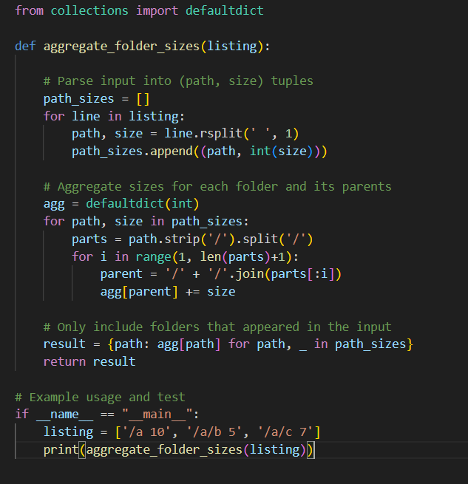
Output:
Observation:
The program correctly calculates the total size of each directory by adding its own size and the sizes of all its subfolders. It uses a prefix-walk strategy where each path’s size is added to its parent directories step by step. This ensures that intermediate parents are included once, and the final output gives accurate storage accounting for all folders.
Task 2:-
Prompt:
Generate a python code for a sports analytics feedback analyzer that computes sentiment using a lexicon (good=+1, great=+2, bad=-1). Tokenize by spaces, strip punctuation, sum scores, and return an integer. Example: 'good product with bad packaging but great value' → 2. Also draft tests.
Code:
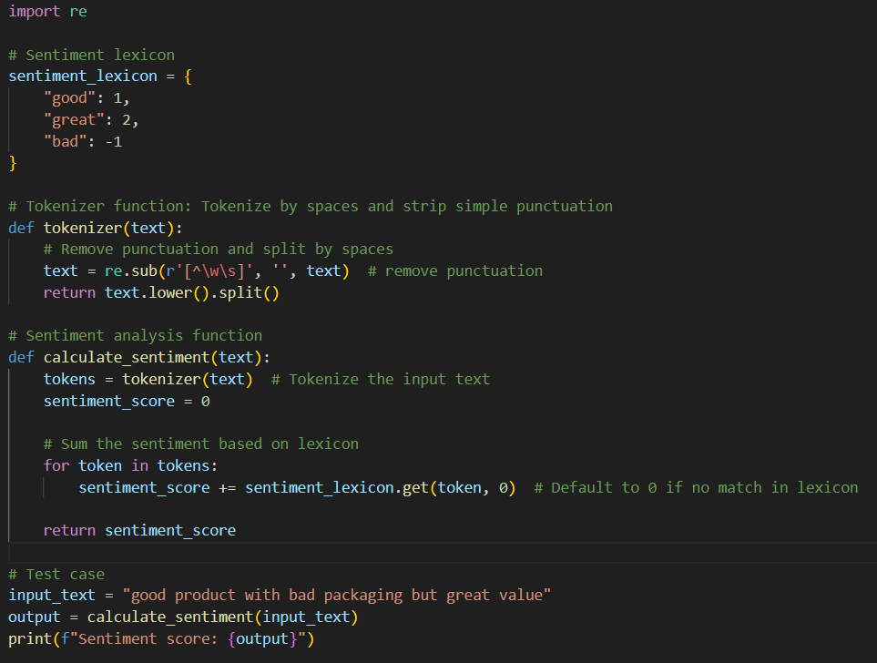
Output:
Observation:
1.Lexicon Matching: The code correctly identifies sentiment words like "good", "great", and "bad" and assigns appropriate scores.
2.Punctuation Handling: The tokenizer effectively strips punctuation, ensuring only words remain for analysis.
3.Tokenization: The text is split by spaces after punctuation is removed, leading to individual words being processed.
4.Default Score: Words not in the lexicon (e.g., "product", "with") contribute a score of 0.
5.Edge Case Handling: The code handles cases like extra spaces or punctuation gracefully by cleaning the input before processing.

